Rural Development Potential Map
[Name of the Region]



Contents

1. Socio-economic profile of the region and its rural areas 3
2. Visualization of the development potential of rural areas in the region 3
3. Overview of E&I Initiatives in the region's rural areas 4

1. Socio-economic profile of the region and its rural areas
[please provide the description, including the following points:
- general description of the socio-economic profile of the region and its rural areas,
- specification of the most important local resources of the region's rural areas,
- description of the identified development potentials of the region's rural areas , including an indication of which of these potentials have been recognized as significant rural development potentials]

2. Visualization of the development potential of rural areas in the region

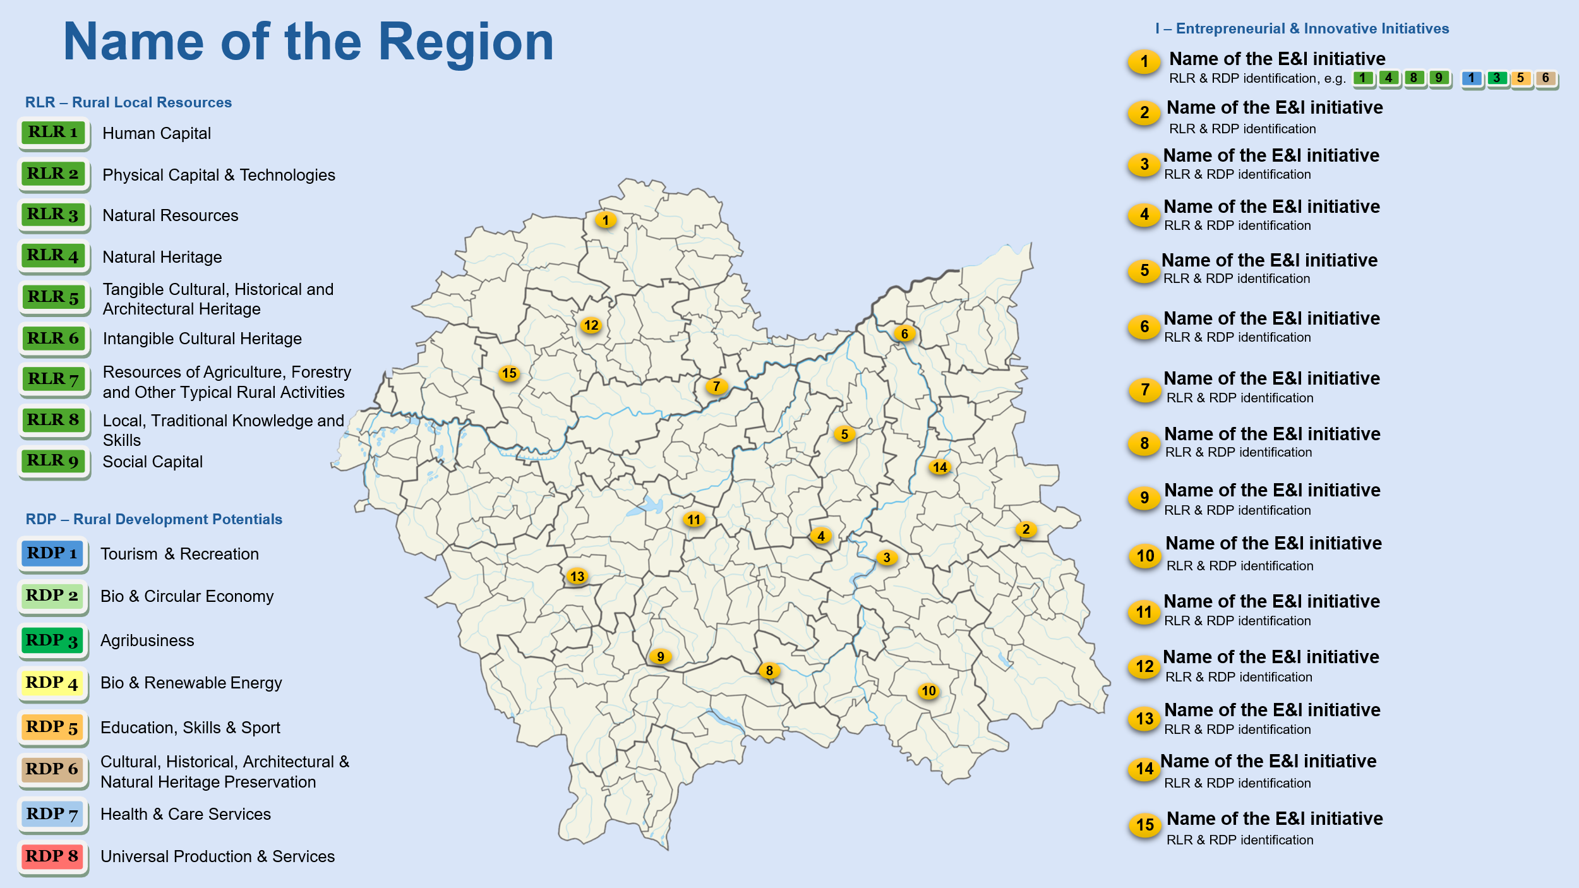
LEGEND
RLR 1,2,3… – Specific Group of Rural Local Resource
RDP 1,2,3… – Category of Key Rural Development Potential
I 1,2,3…- Entrepreneurial & Innovative Initiative

3. Overview of E&I Initiatives in the region's rural areas

3.1. Initiative 1

1. Initiative characteristics:

1.1. Name of the initiative:

1.2. Location of the initiative:

1.3. Type of stakeholder involved:

1.4. Initiative type: (business, social, mixed)

1.5. Scale of activity: (small, medium, large)

1.6. Legal form: (e.g., sole proprietorship, social cooperative, association)

1.7. Planned implementation period: (e.g., 1 year, 3 years, long-term project)

2. Description of initiative:
(Please describe the initiative, including its scope, activities, and objectives)

3. The main rural local resources that form the basis of the initiative:
(Please indicate the main rural resources which are needed for the initiative)

4. The development potential(s) of rural areas that the initiative utilizes:
(Please select the type of rural area potential that the initiative addresses)

Development potentials:
Tourism & recreation
Bio & circular economy
Bio & renewable energy
Education, skills & sport
Agribusiness
Cultural, historical, architectural& natural heritage preservation
Health & care services
Universal production & services

5. Entrepreneurial and innovative knowledge, skills, and competencies required for the implementation of the initiative:
(please detail the specific skills, knowledge, and competencies that are essential for the successful implementation of the initiative)

6. Key rural stakeholders supporting the initiative:
(Please provide a list of key stakeholders whose engagement or support is crucial for the success of the initiative)

7. Socio-economic barriers and challenges related to the initiative:
(Please describe the potential challenges and obstacles that may hinder the success of the initiative)

3.2. Initiative 2

3.3. Initiative 3

3.4. Initiative 4

3.5. Initiative 5

3.6. Initiative 6

3.7. Initiative 7

3.8. Initiative 8

3.9. Initiative 9

3.10. Initiative10

3.11. Initiative 11

3.12. Initiative 12

3.13. Initiative 13

3.14. Initiative 14

3.15. Initiative 15

